**Submitted by: Submitted to:**

**NAME: Rahul Gusain Hitesh Kumar Sharma**

**SAP: 500084143**

**ROLL NO.: R214220900**

**BATCH: 1 DevOps**

# Build and Release Management

**LAB EXERCISE 2**

**Q1. Write a program in java to find the sum of two numbers and test this unit with the JUnit tool.**

**Step 1:-** First we will create a Maven Project and then design a Class for performing the sum of two numbers.

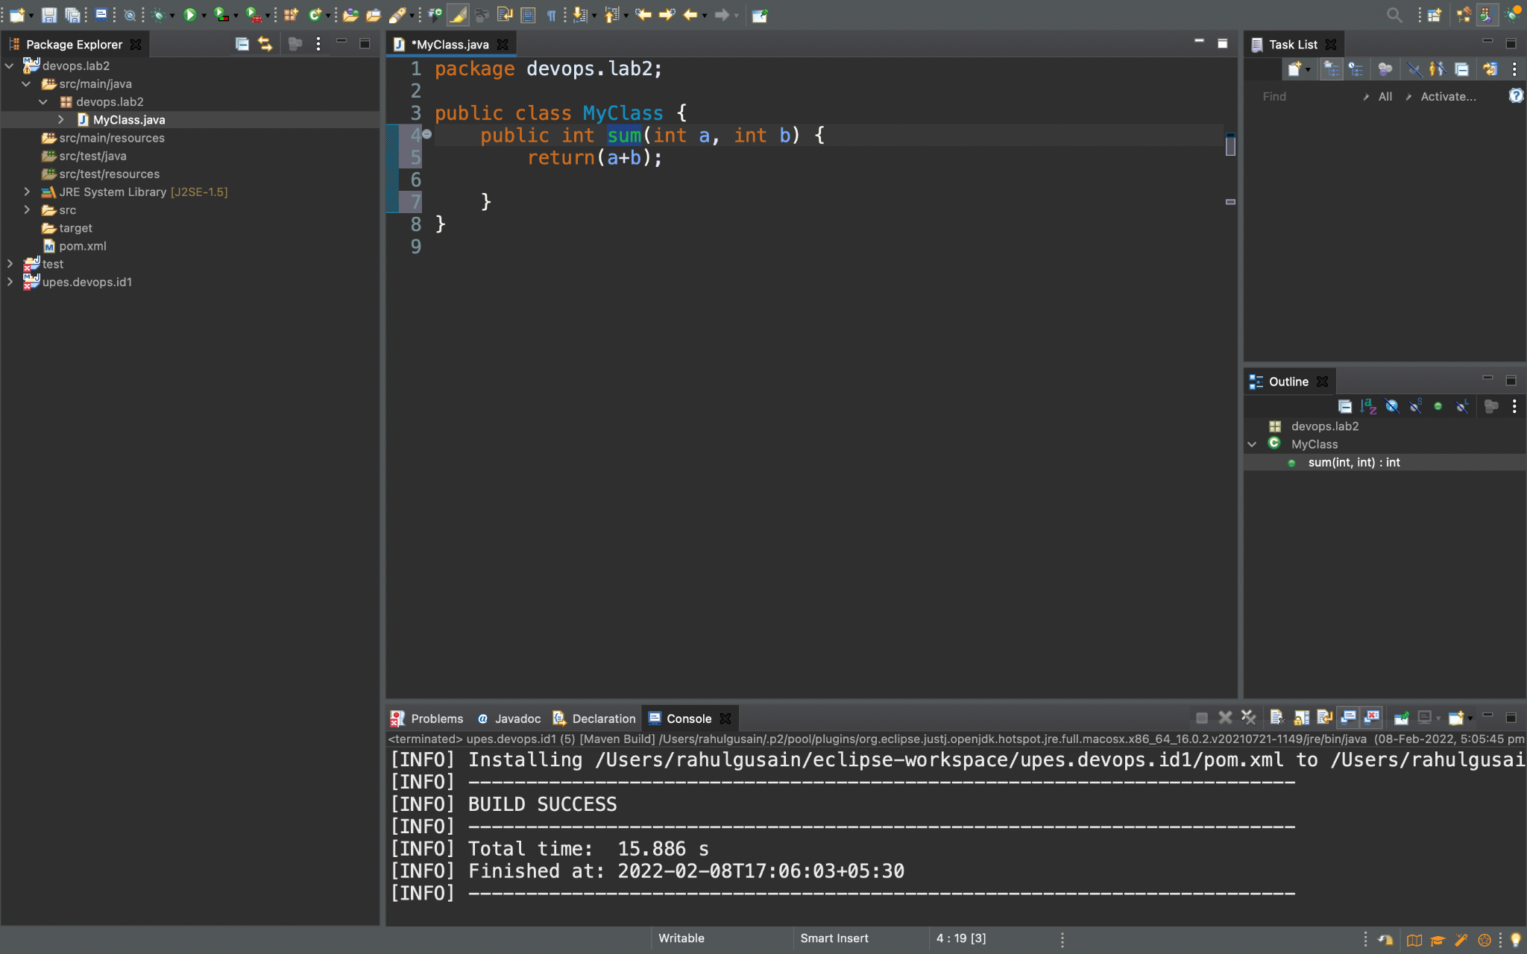**Code:-**

**package** devops.lab2;

**public** **class** MyClass {

**public** **int** sum(**int** a, **int** b) {

**return**(a+b);

}

**Step 2:-** Click on new and then on Junit Test Case

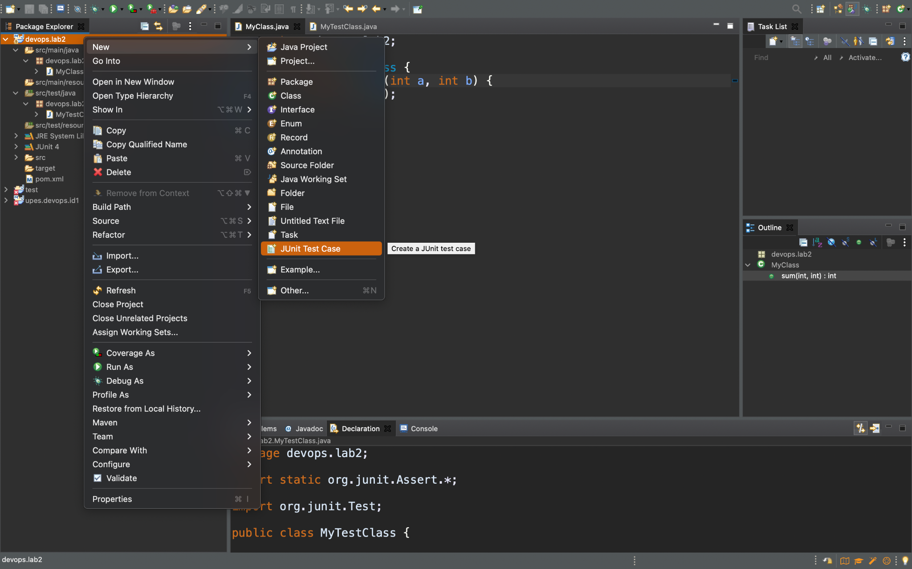

**Step 3 :-** Now Add the Class Name and click on finish.

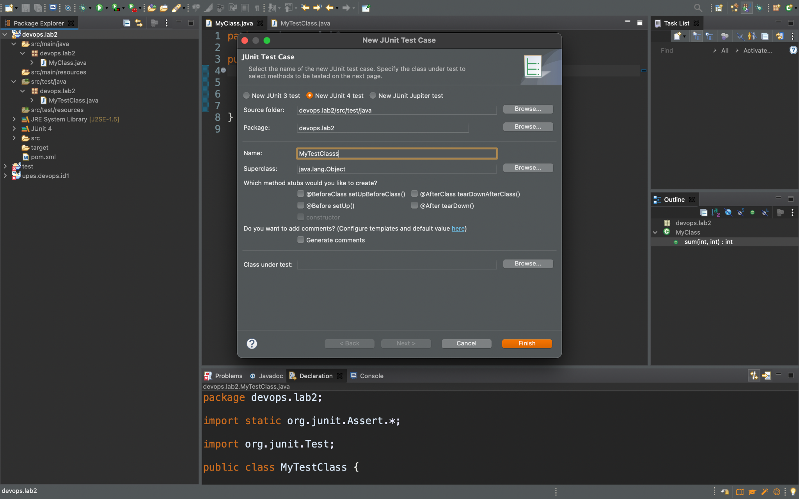

**Step 4 :-** In this step a code we can already see a code but we will do some changes for our test.

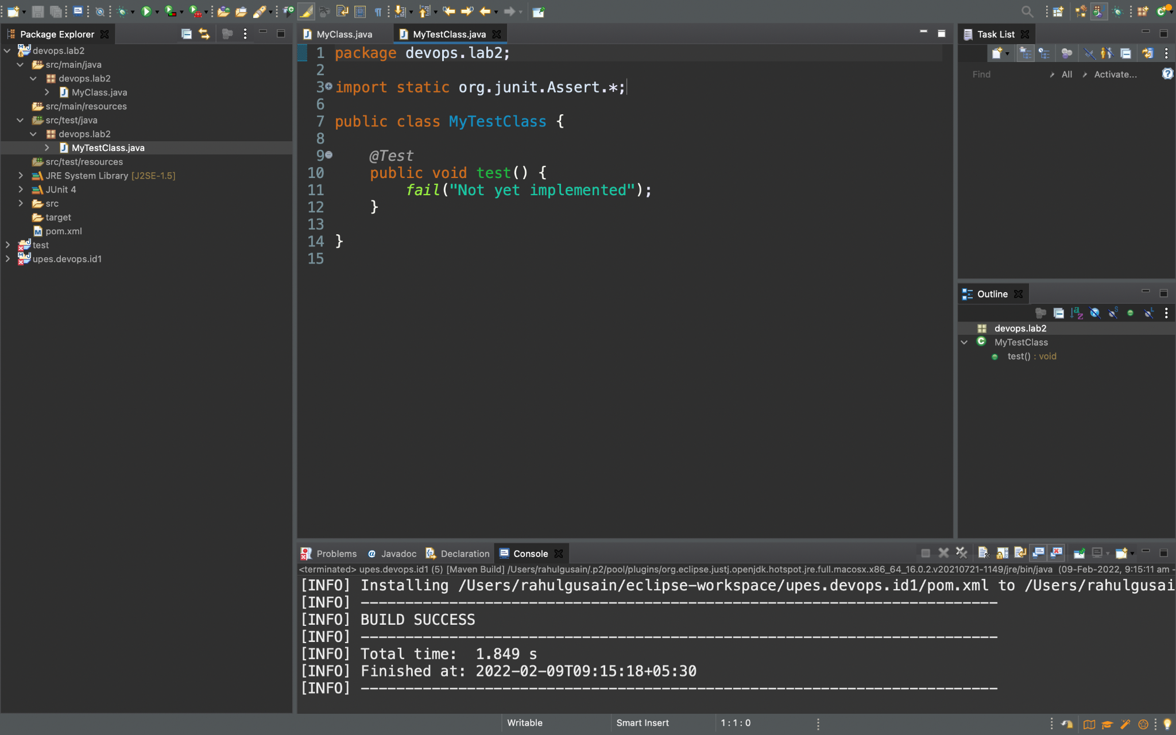**We will see some code already written but we will change the line under function test and give the inputs. Updated Code is given below.**

**Code :-**

**package** devops.lab2;

**import** **static** org.junit.Assert.*;

**import** org.junit.Test;

**public** **class** MyTestClass {

@Test

**public** **void** test() {

MyClass obj = **new** MyClass();

*assertEquals*(14,obj.sum(10, 4));

}

}

**Step 5 :-** Now by right clicking on our project and then Run as and then click on Maven test.

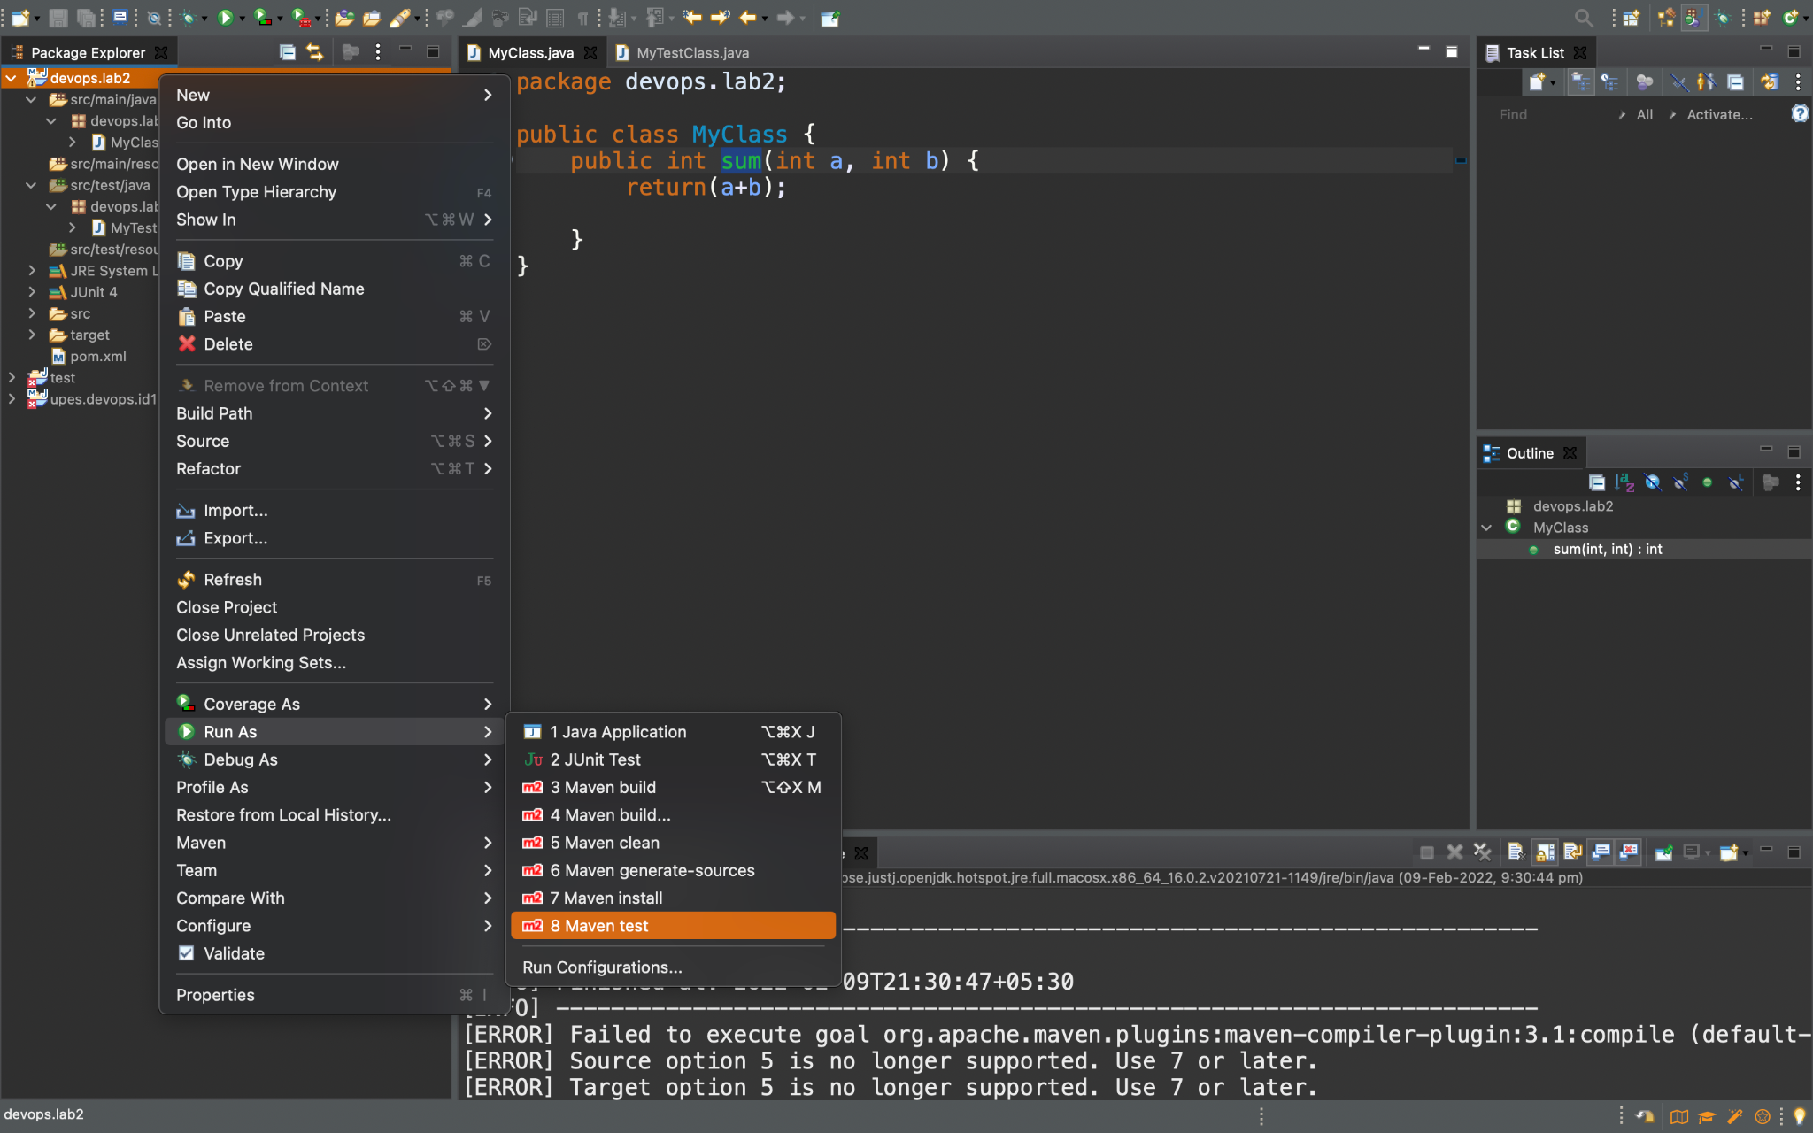

**After compiling we will see many errors first is the error of the java version for which we will add the given dependency in Pom.XML file.**

<properties>

<maven.compiler.source>1.8</maven.compiler.source>

<maven.compiler.target>1.8</maven.compiler.target>

</properties>

**And for the another error we will add the given dependency on Pom.XML file.**

<dependencies>

<dependency>

<groupId>junit</groupId>

<artifactId>junit</artifactId>

<version>4.12</version>

<scope>test</scope>

</dependency>

</dependencies>

This all will remove the errors which arises because we are using different versions of different tools. We get all the dependencies from the central mvn repository which is maintained by Apache Foundation.

**Step 6 :-** Now again we will Execute our Junit test.

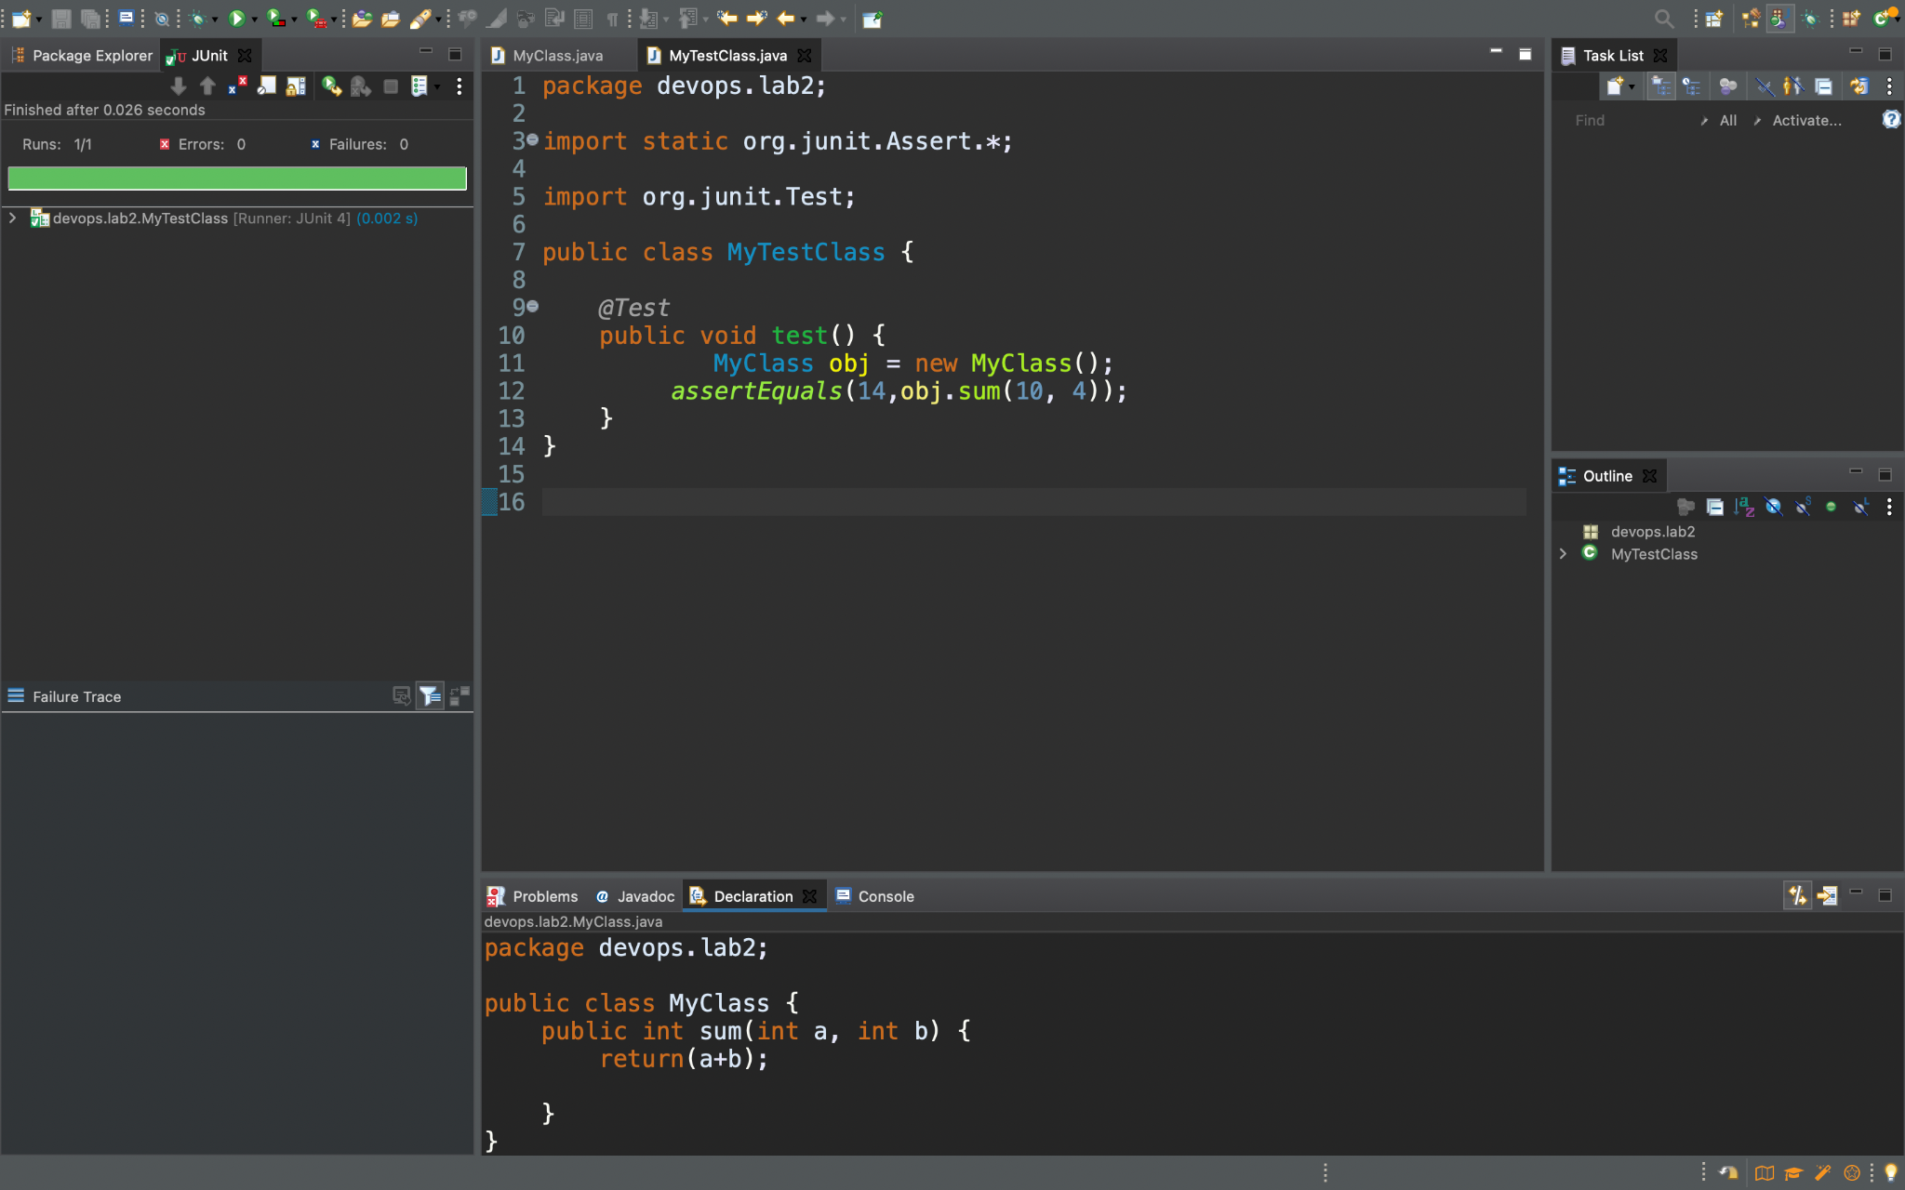

Now we can clearly see that the it is done successfully as we can see the green colour and it’s written Run 1/1 , Errors :0 and Failure :0

**Step 7 :-** Now as we want to check it using maven so we will right click on the class and then on Run As and then on Maven test.

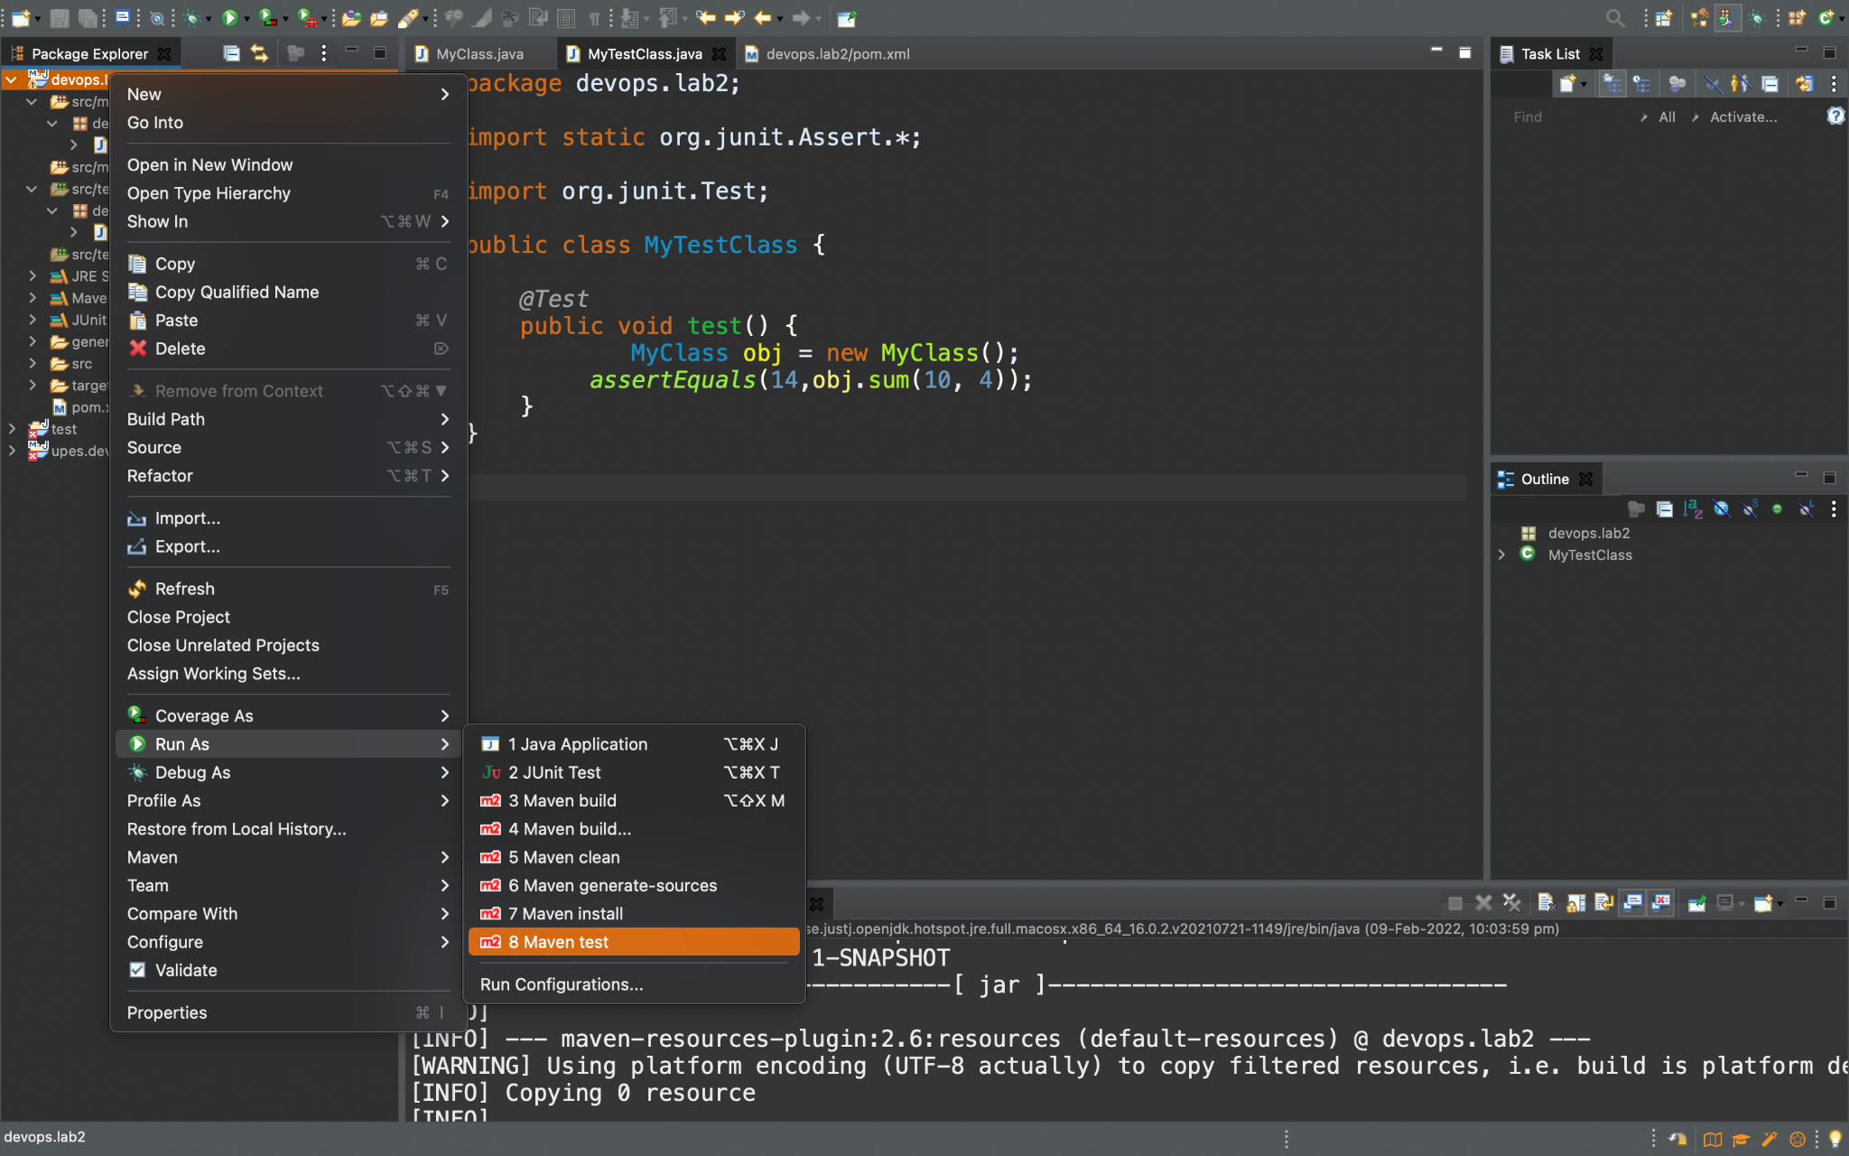

**We can check that now it shows that the build is successful.**

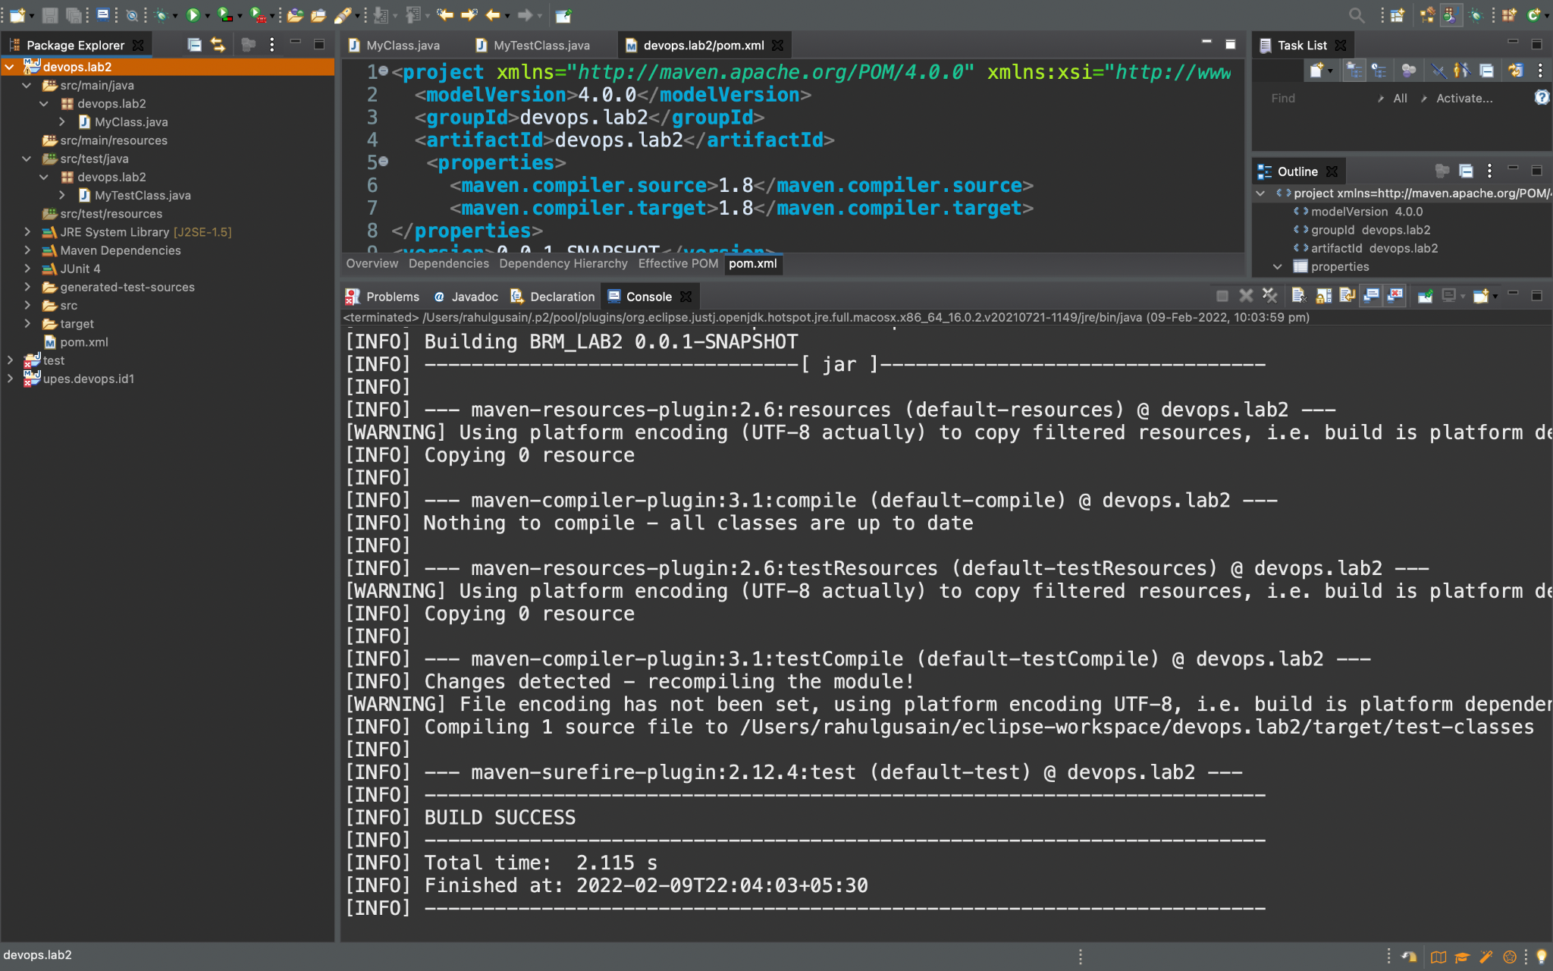

**Q2. Write a program in Java to find the reverse of a number and test it using the JUnit tool.**

**Step 1:-** First we will create a Maven Project and then design a Class for performing the reverse of given number.

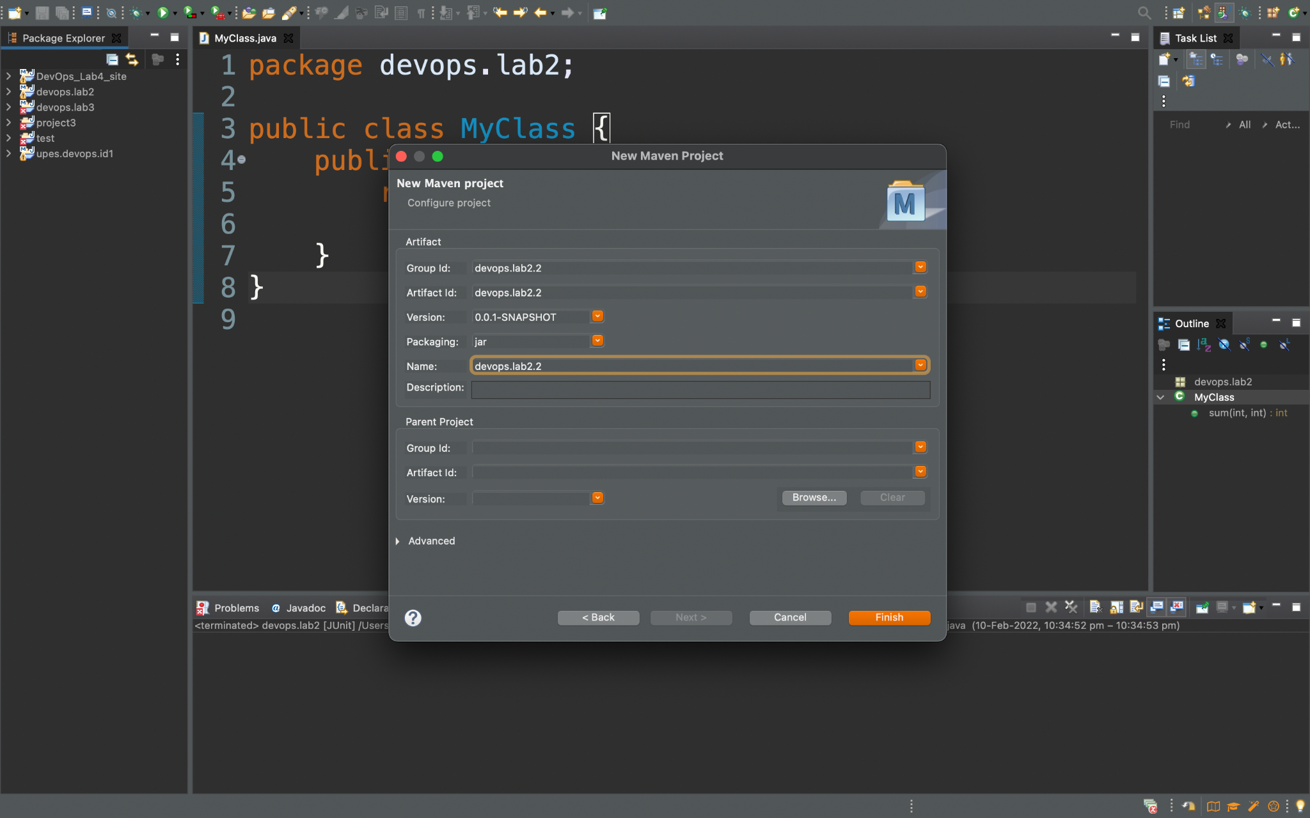

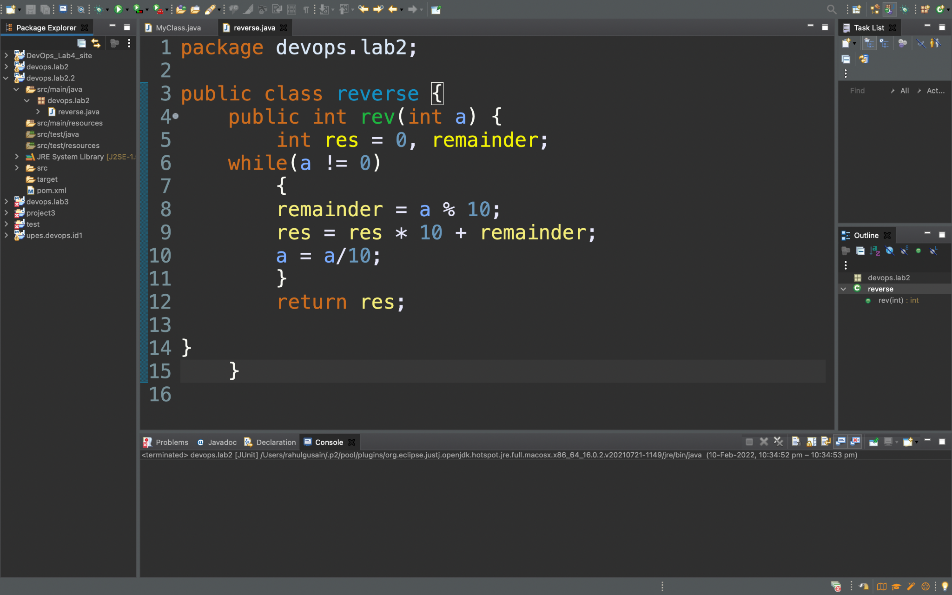

**Step 2:-** Click on new and then on Junit Test Case



**Step 3 :-** Now Add the Class Name and click on finish.

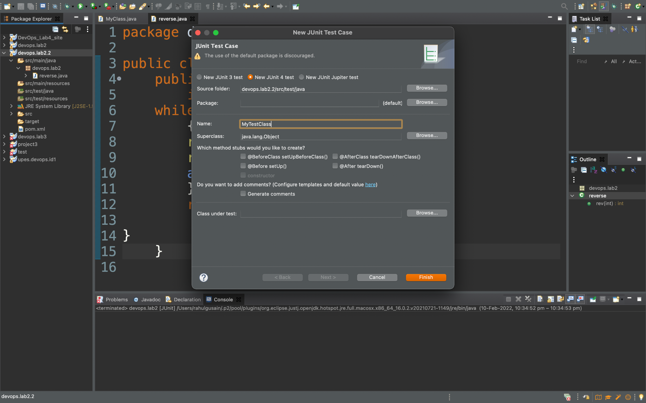

**Step 4 :-** In this step a code we can already see a code but we will do some changes for our test.

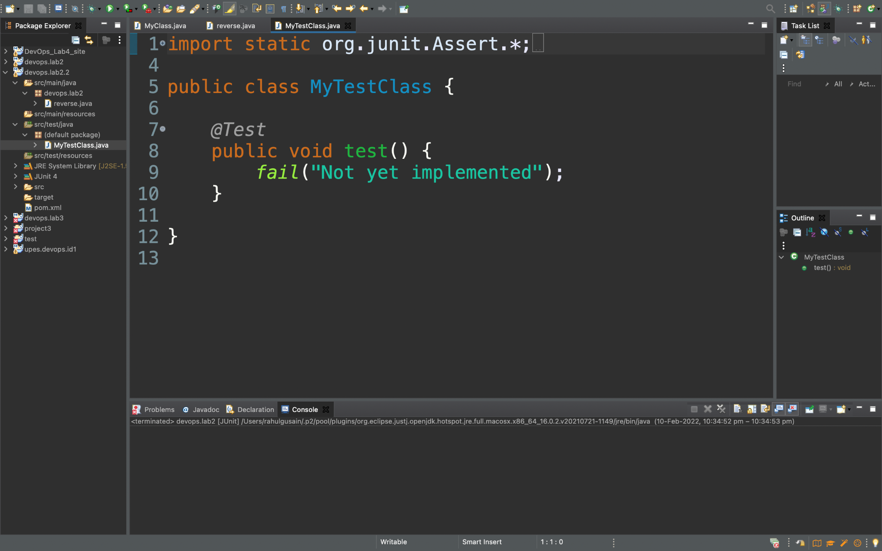

**We will see some code already written but we will change the line under the function test and give the inputs. 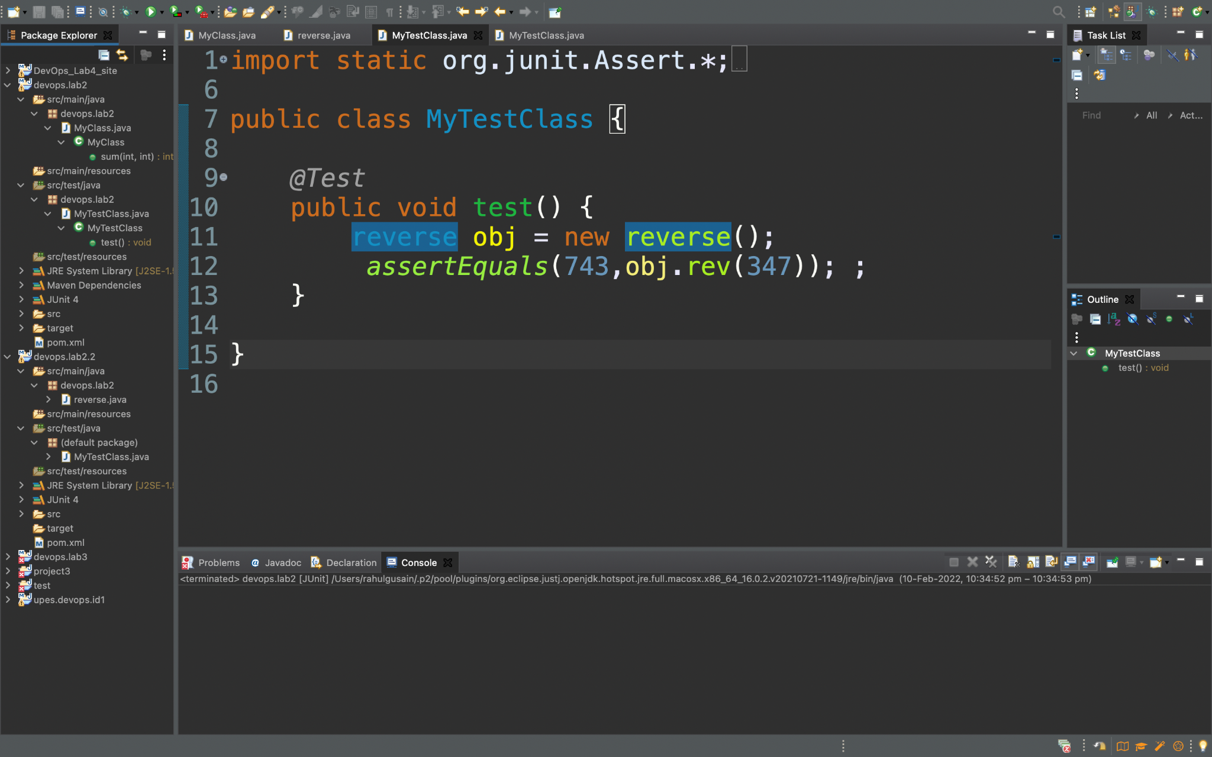Step 5:-** Now by right-clicking on our project and then Run as and then click on Maven test.

**After compiling we will see many errors first is the error of the java version for which we will add the given dependency in Pom.XML file.**

<properties>

<maven.compiler.source>1.8</maven.compiler.source>

<maven.compiler.target>1.8</maven.compiler.target>

</properties>

**And for the another error we will add the given dependency on Pom.XML file.**

<dependencies>

<dependency>

<groupId>junit</groupId>

<artifactId>junit</artifactId>

<version>4.12</version>

<scope>test</scope>

</dependency>

</dependencies>

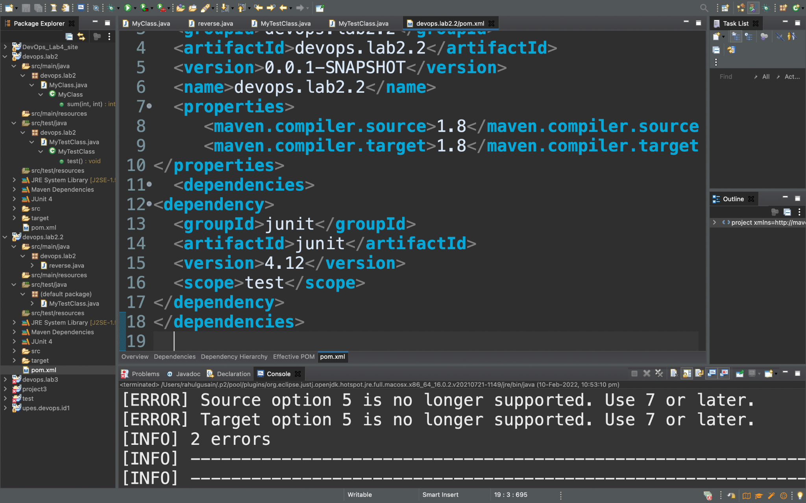

This all will remove the errors which arise because we are using different versions of different tools. We get all the dependencies from the central mvn repository which is maintained by Apache Foundation.

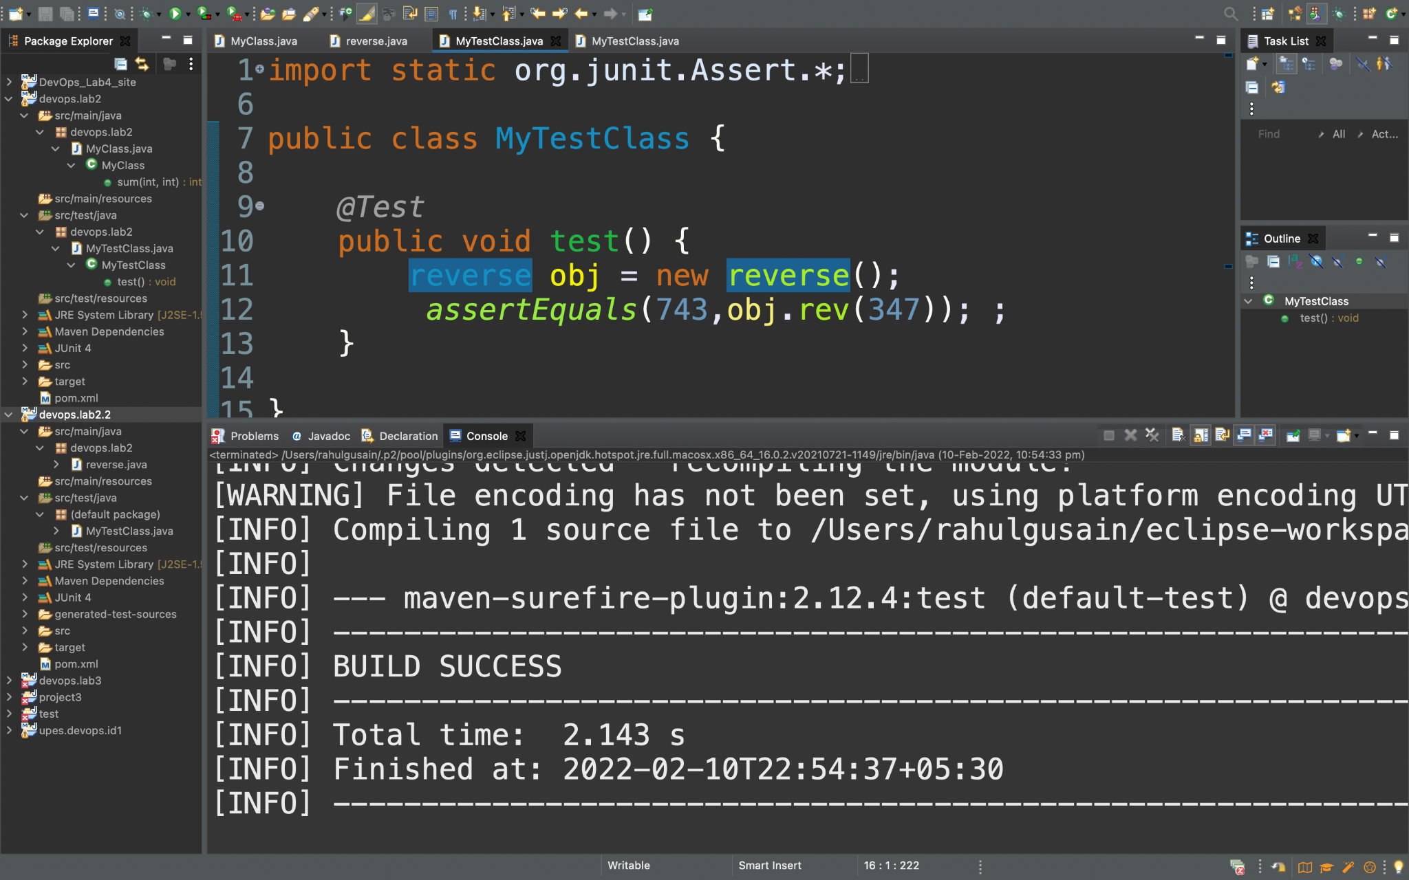

**Step 6 :-** Now again we will Execute our Junit test.

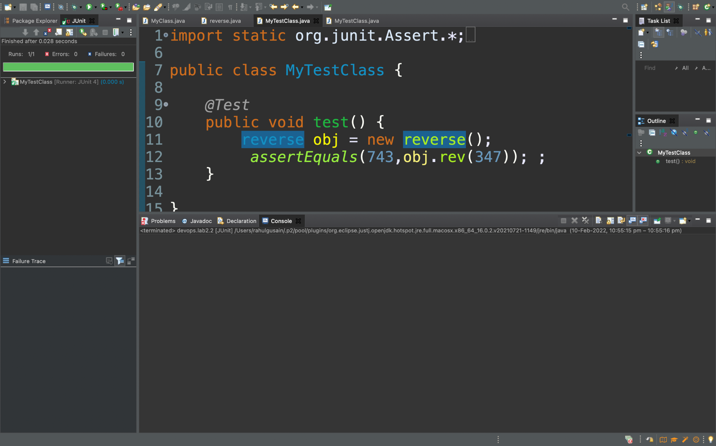

**Now we can clearly see that it is done successfully as we can see the green colour and it’s written Run 1/1, Errors :0 and Failure :0**

**Step 7 :-** Now as we want to check it using maven so we will right click on the class and then on Run As and then on Maven test.

